Docker Task

Install docker on EC2 and explore the docker commands (docker images, containers, volumes, network)
STEP 1: Launch EC2 Instance
- Go to AWS Console → EC2 → Launch Instance. Choose OS:
  - Preferred: Amazon Linux 2 or Ubuntu 22.04
- Instance Type: t2.micro. Select Key Pair. Security Group:
  - Allow SSH (Port 22)
- Launch the instance. SSH into EC2 via Putty.
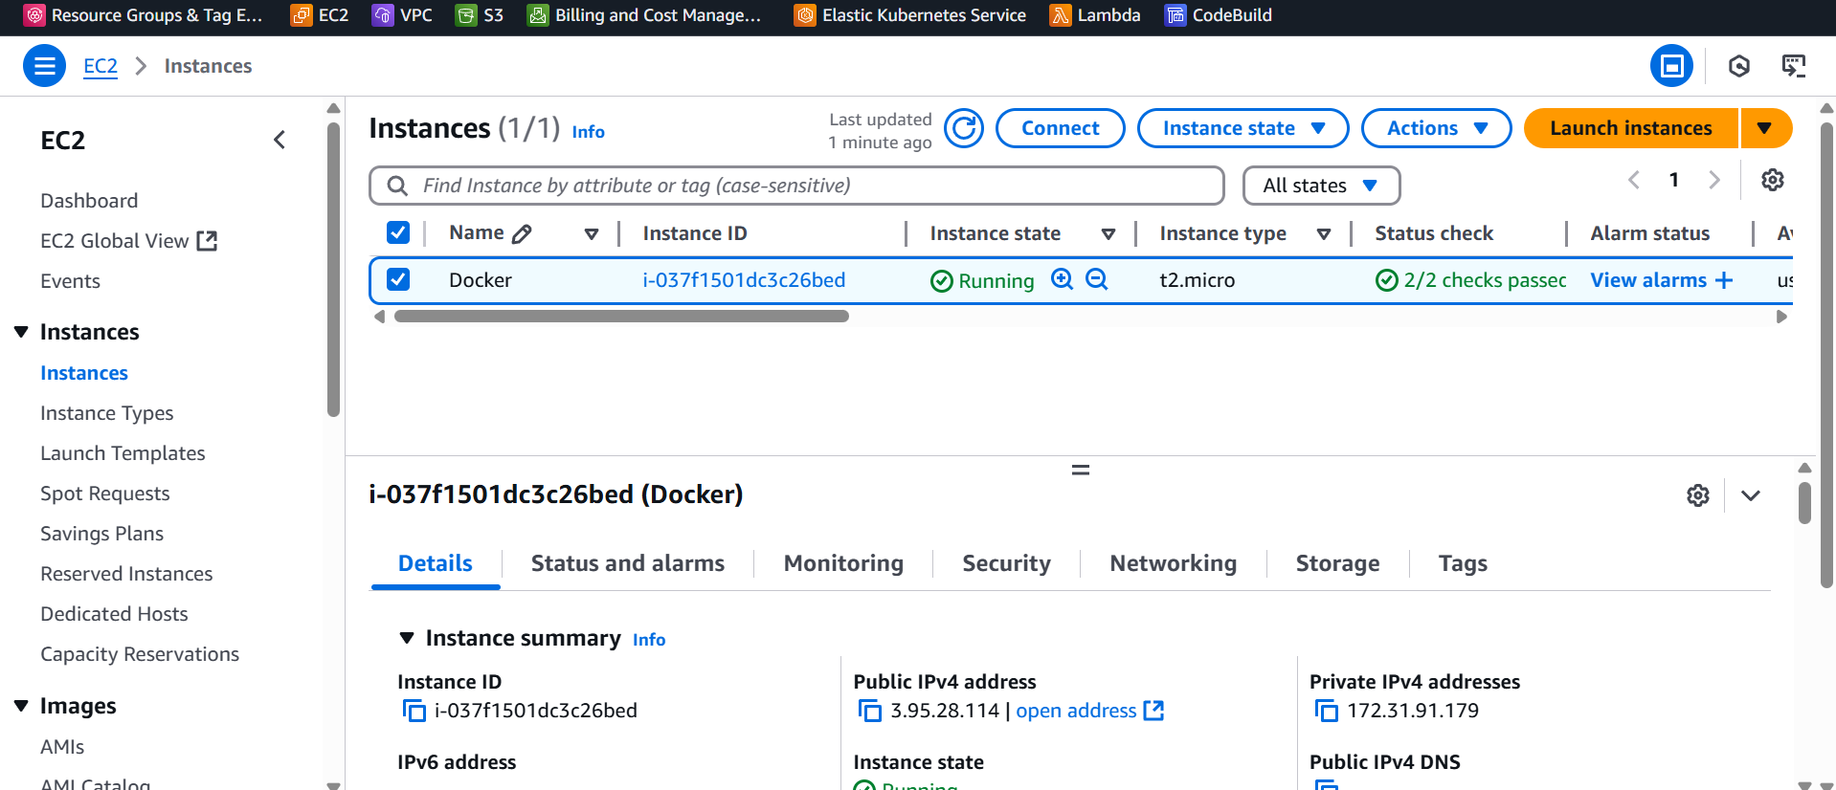
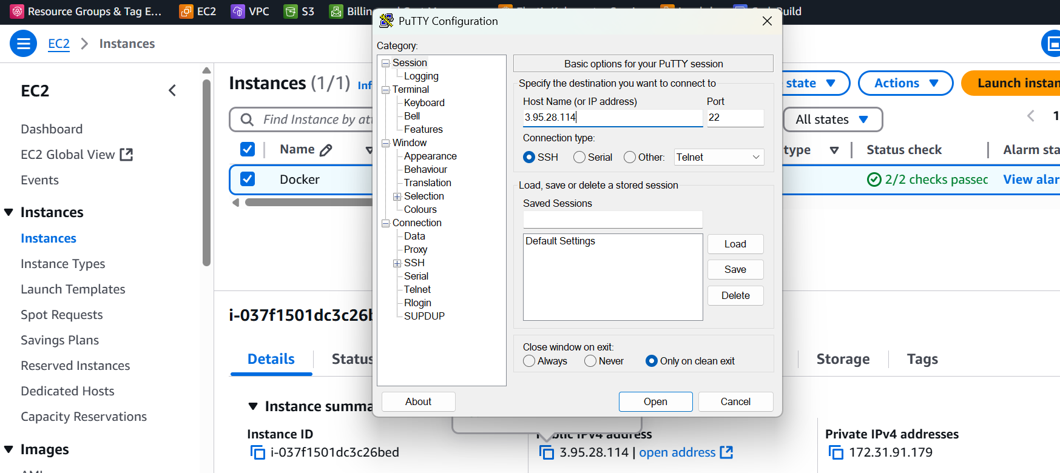

STEP 2: Install Docker
sudo apt update
Sudo apt install docker.io -y
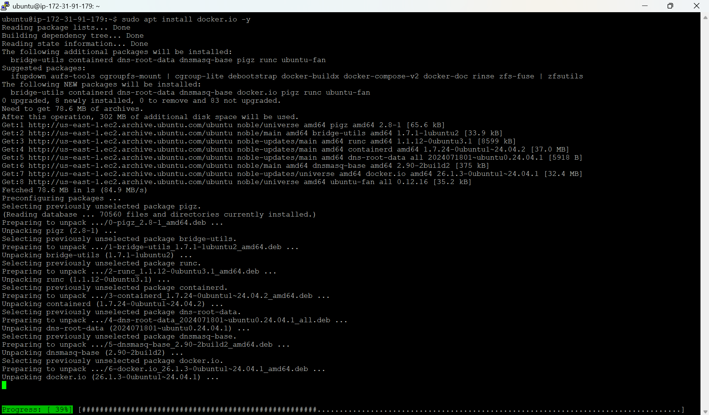
Docker --version
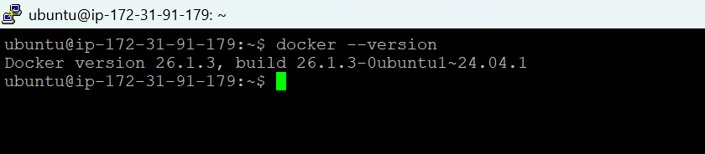

Docker Images
docker pull nginx
docker images
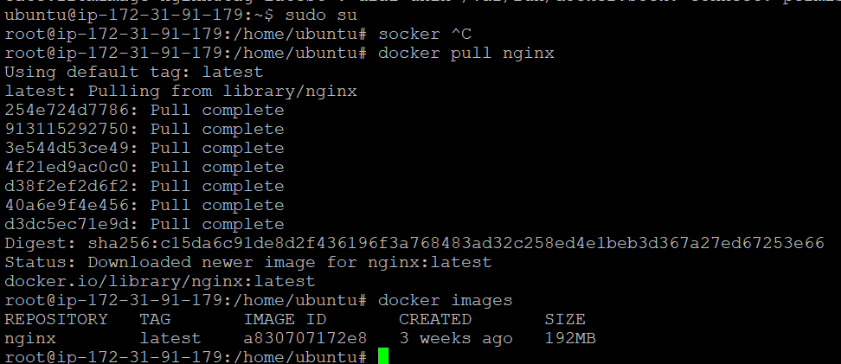
Docker Containers
Docker run -d - -name myngnix -p 8080:80 nginx
Docker ps

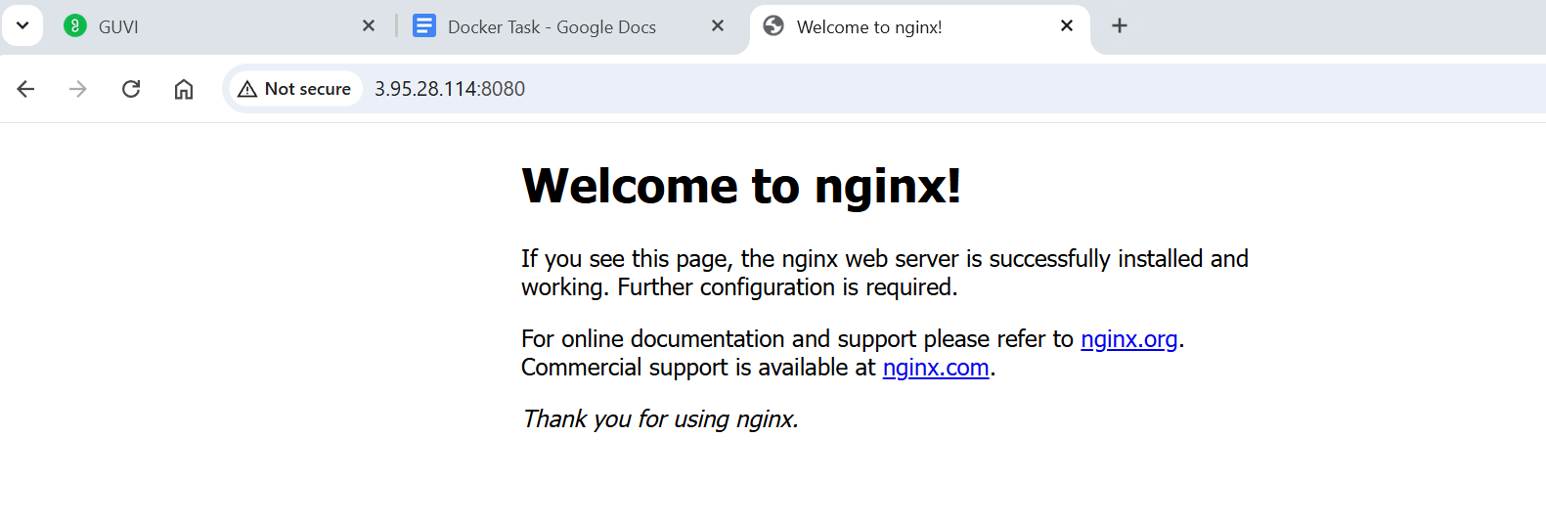
Docker Volumes:
docker volume create mydata
docker volume ls

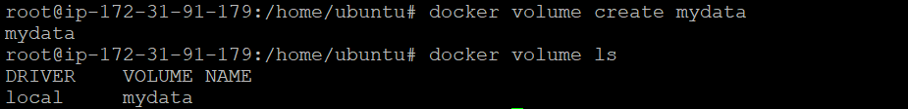
Docker Networks
docker network ls
docker network create app-net
docker run -d --name mysql-db --network app-net -e MYSQL_ROOT_PASSWORD=my-secret-pw -e MYSQL_DATABASE=testdb mysql:latest
docker run -it –rm --network app-net mysql mysql -h mysql-db -u root -p
